Experiment No. 3.2

Student Name: Parvinder Singh UID: 22MCC20043
Branch: MCA - CCD Section/Group: 22MCD-1/ Grp B
Semester: III

Subject Name: Business Analytical Lab Subject Code: 22CAH-703
- Aim/Overview of the practical: Implementation of reports in Tableau.

- We use BI tools like Tableau to collect, prepare, visualize and analyze the data. By doing this, we are basically making sense of raw data by converting it into meaningful information like charts, tables, graphs, maps, etc.
- Reporting is used for the same purpose in any BI tool. More the reporting options in a BI tool, the better the tool. Tableau has managed to secure a top spot in the charts for its wholesome reporting functionalities.
- Step to create Dashboard in Tableau:

- Step 1: Open a Tableau Worksheet
The first step in creating a report is to know your Tableau worksheet and its elements completely. A Tableau worksheet or sheet is like a report canvas or editor where we have all the tools and functionalities to create a complete report using our data.
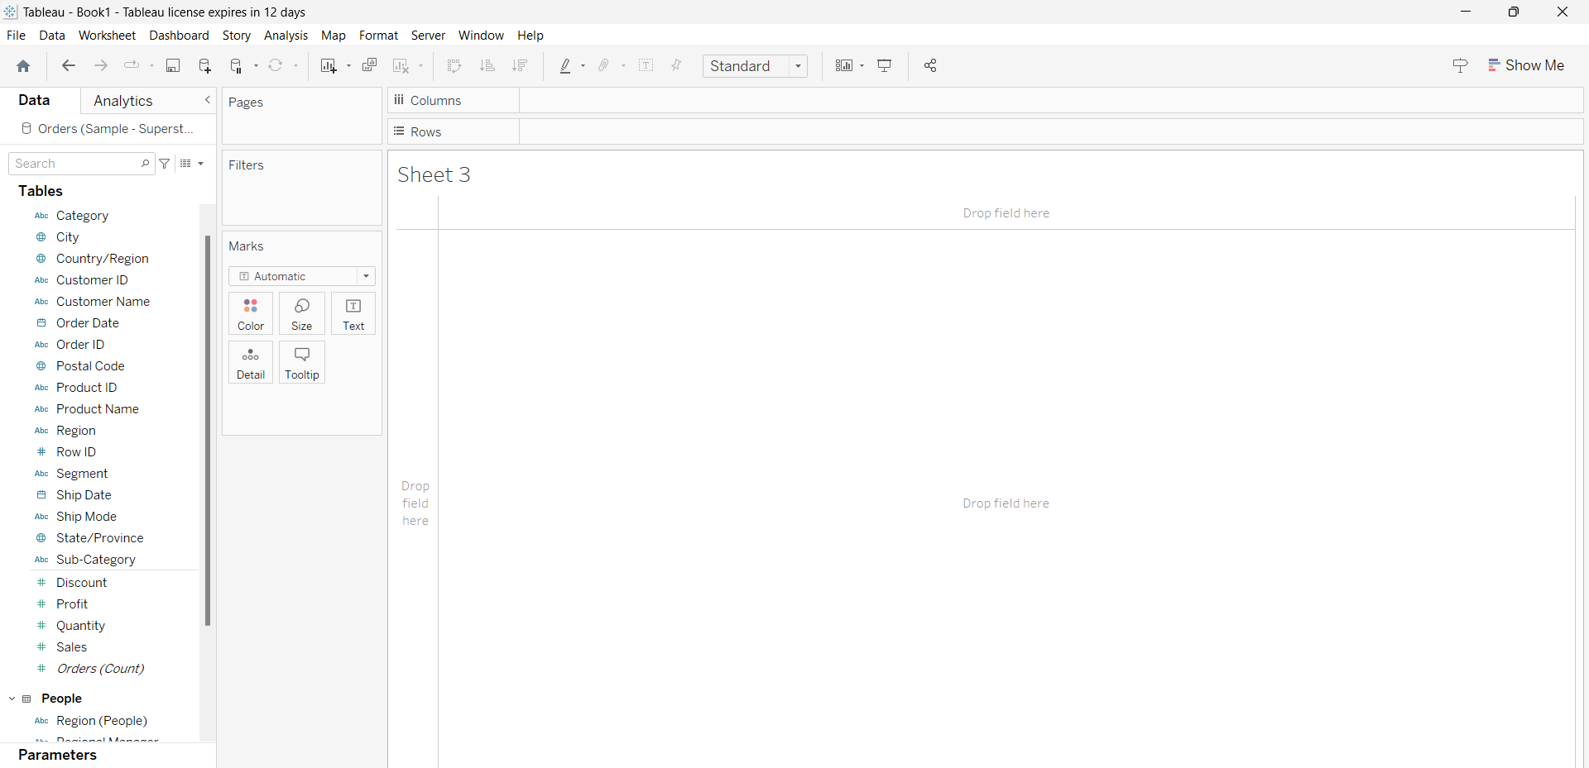

- Step 2: Add Dimensions and Measures
To create a report you need to create visualizations as per your business requirements like a pie chart, bar graph, stacked bar graph, map, histogram, etc. To initiate creating a visualization, drag and drop a field in the Rows or Column section.
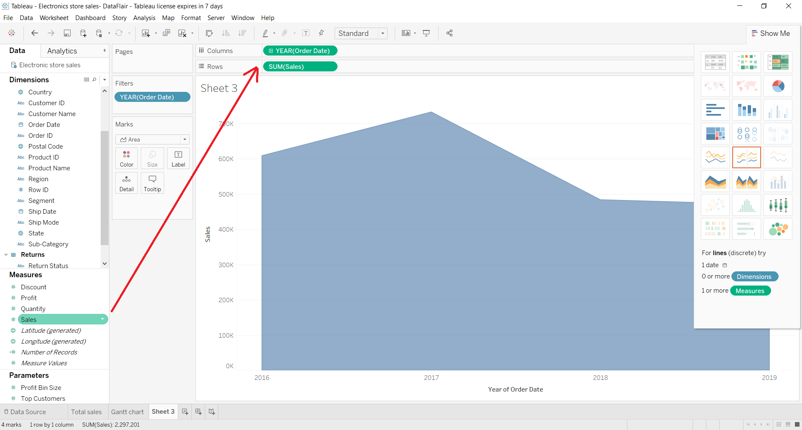

- Step 3: Create a Visualization
After following certain steps, your visualization will be ready. You can learn how to create different types of visualizations available in Tableau in separate tutorials available in our Tableau tutorial package. Here, we have shown a discrete area chart.
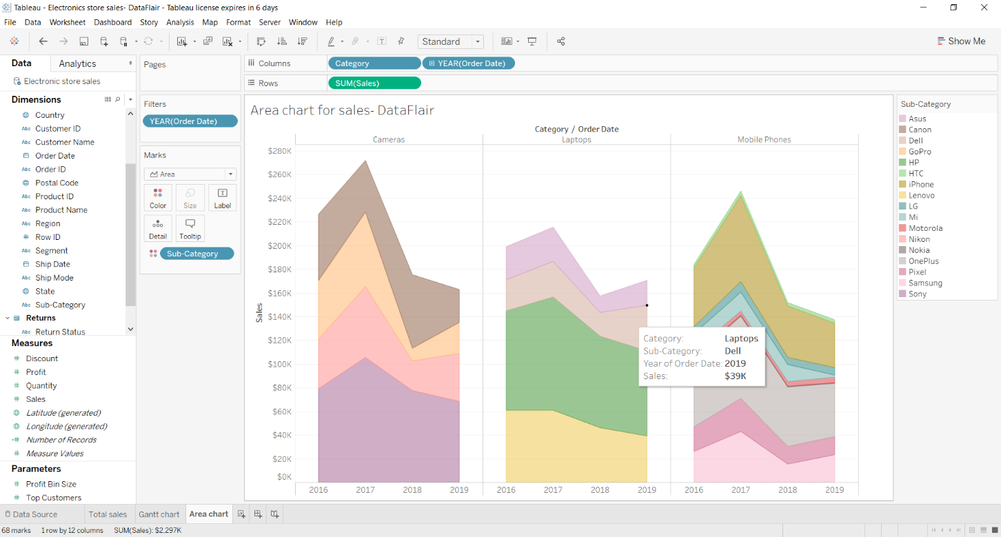
- Step 4: Create More Visualizations
We can create more visualizations on separate sheets so that we can bring them together while creating a report.
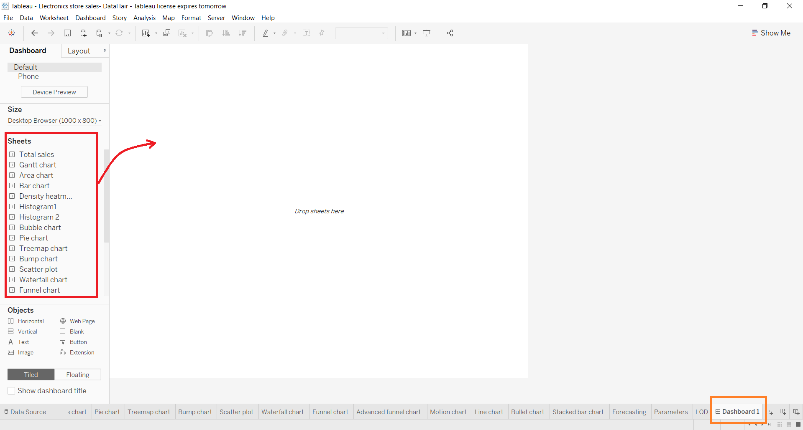

- Step 5: Create a Dashboard
To create a dashboard, open a fresh dashboard from the dashboard tab and add visuals to it. You can drag and drop visuals from the list of them given in the Sheets section. After adding visuals, you can adjust them on the dashboard as per your liking.
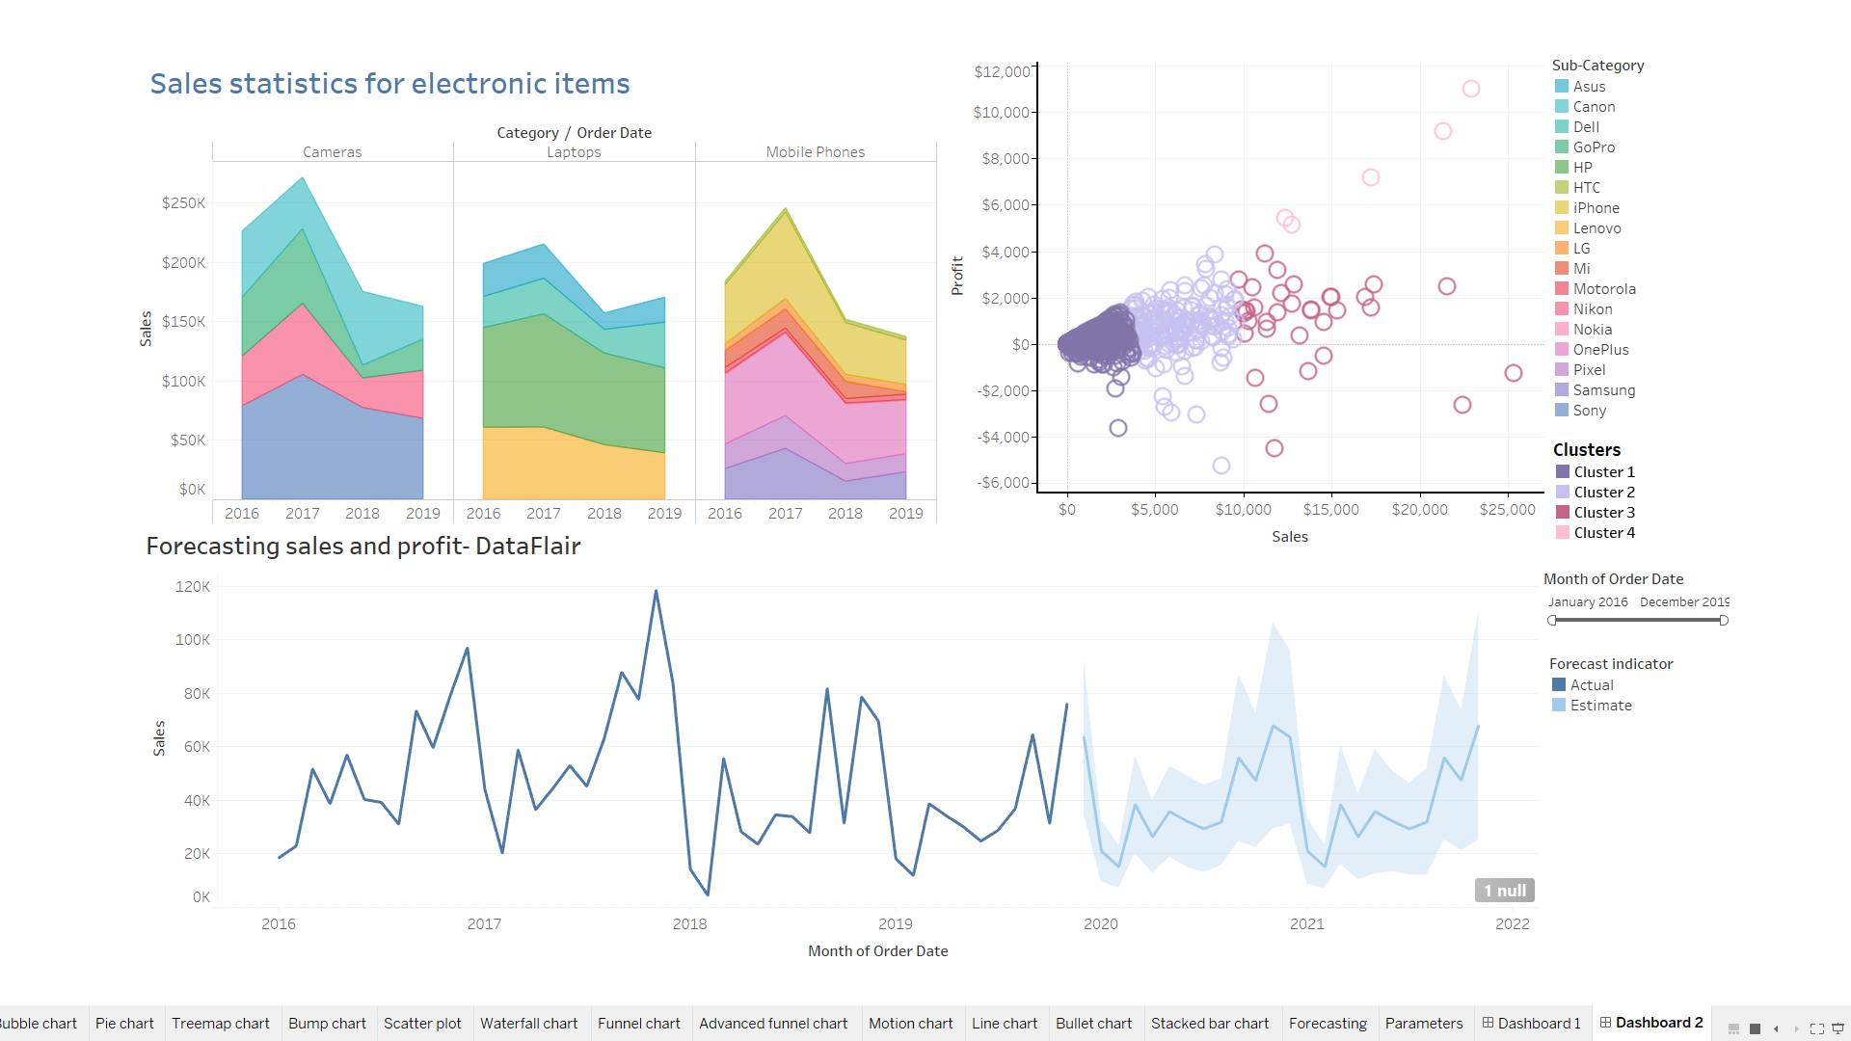

- Step 6: Share Dashboard as Report
Once you complete a dashboard with all its elements in place you can share it as a report with other users. The dashboard can also be called a workbook as it contains a collection of worksheets.
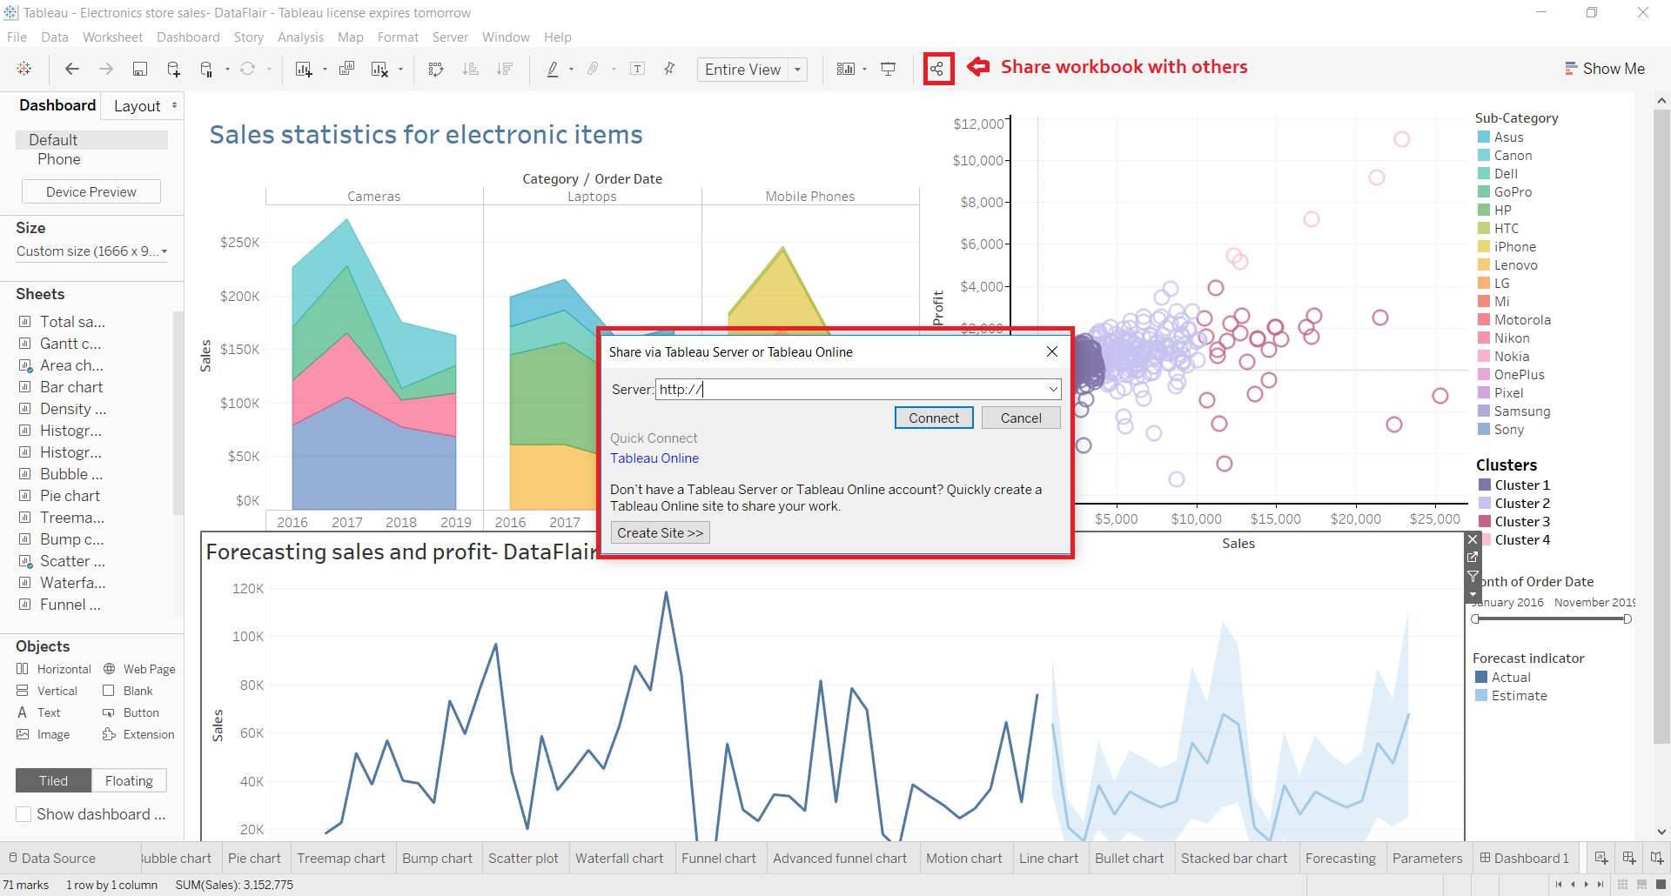

Learning outcomes (What I have learnt):

- Implementation of Tableau report.
- Apply a variety of analytical methods.
- Create and interpret Tableau visualizations.

